This section includes editing notes to assist the user in editing the section to suit project requirements. These notes are included as hidden text, and can be revealed or hidden by one of the following methods:

Microsoft Word 2013: Display the FILE tab on the ribbon, click OPTIONS, then DISPLAY. Select or deselect HIDDEN TEXT.

Microsoft Word 2010: Display the FILE tab on the ribbon, click OPTIONS, then on left menu click on DISPLAY. Under ALWAYS SHOW THESE select or deselect HIDDEN TEXT.
Released 11/2018

SECTION 09 28 13

CEMENTITIOUS BACKER BOARDS

- GENERAL
  - SUMMARY
    - Section Includes:
      - Baseboard and underlayment for interior and exterior applications

  - RELATED SECTIONS

    - Division 01: Administrative, procedural, and temporary work requirements
    - Section [09 21 16.33 - Gypsum Board Area Separation Wall Assemblies]
    - Section [09 30 00 – Tiling]
    - Section [22 41 23 Residential Showers]
    - Section [22 42 23 Commercial Showers]
    - Section [22 43 23 Healthcare Showers]
    - Section [22 45 13 Emergency Showers]
    - Section [22 46 19 Security Showers]
  - REFERENCES

    - American National Standards Institute (www.ANSI.org)
      - A118.9 - Test Methods and Specifications for Cementitious Backer Units.
      - A118.10 - American National Standard Specifications for Load Bearing, Bonded, Waterproof Membranes for Thin-set Ceramic Tile and Dimension Stone Installation.
      - A108.11 - Interior Installation of Cementitious Backer Units.
    - ASTM International (www.ASTM.org)
      - C947 Standard Test Method for Flexural Properties of Thin-Section Glass-Fiber-Reinforced Concrete
      - C1325 Standard for Non-Asbestos Fiber-Mat Reinforced Cementitious Backer Units
      - C1629 - Standard Classification for Abuse-Resistant Non-decorated Interior Gypsum Panel Products and Fiber-Reinforced Cement Panels
    - Tile Council of North America (www.TCNAtile.org)
      - TCNA Handbook.
  - SUBMITTALS

    - Submit under provisions of Section [01 30 00] - Administrative Requirements.
    - Manufacturer's data:
      - Each product to be installed
      - Accessory data
      - Installation requirements
      - Installer acceptance

    - Sustainable Design Submittals:
      - Regional Materials
      - Low-Emitting Materials
  - QUALITY ASSURANCE
    - Manufacturer Qualifications: Ten (10) years manufacturing moisture resistant backer boards.
    - Installer Qualifications: Five (5) years commercial tile or drywall installation experience.
  - DELIVERY, STORAGE, AND HANDLING
    - Deliver, store and handle product following manufacturer instructions.
    - Store indoors in manufacturer's packaging and protect from damage prior to installation.
    - Inspect panels for damage and notify manufacturer of materials requiring replacement.
  - PROJECT CONDITIONS
    - Weatherproof and enclose building to maintain a minimum of 60 degrees F (15 degrees C) and 60% relative humidity.
  - WARRANTY
    - Provide manufacturer's standard thirty five (35) year repair or replacement warranty.
- PRODUCTS
  - MANUFACTURERS
    - Acceptable Manufacturer: FinPan, Inc. Hamilton, OH 45015; (800) 544-7398; www.finpan.com

    - Substitutions: [Not permitted] [In accordance with Section 01 16 00]
  - MATERIALS

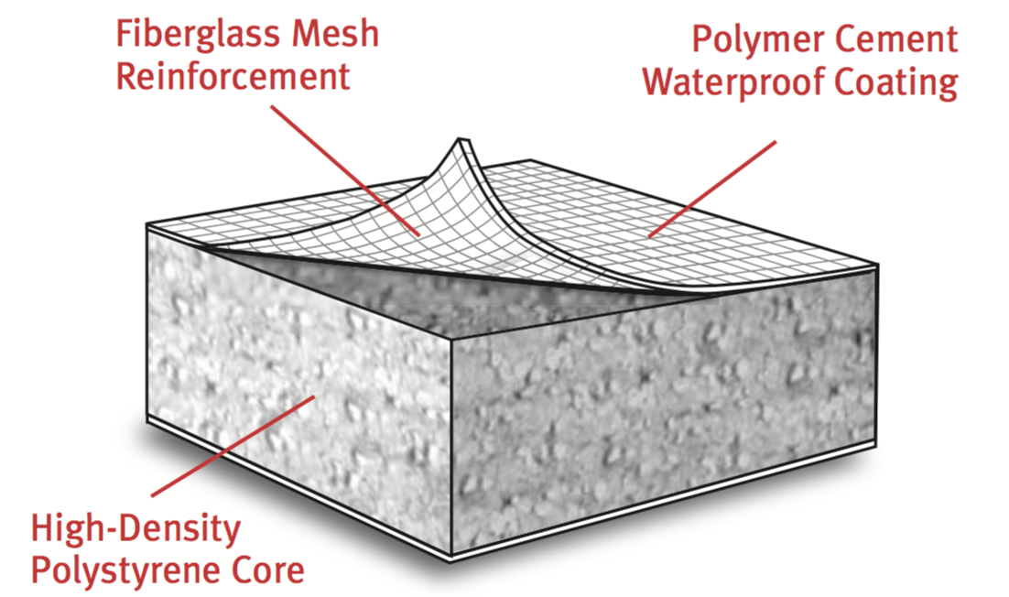
    - Lightweight waterproof, insulated polystyrene polymer cement coated board
      - Product: ProPanel by FinPan, Inc.
      - Composition: High-density expanded polystyrene, double sided fiberglass mesh reinforced
cement panel
      - ANSI A118.10: Section 4-5 Waterproofness
      - Thickness: [1/4 inch (6mm)] [1/2 inch (13mm)]
      - Weight: 6 pounds per panel
      - Width: 3 feet (914 mm).
      - Length: 5 feet (1524 mm).
      - Edges: Square.
      - Density: 2 lb. Density EPS Core
      - ASTM D4068: Pass, hydrostatic Water Pressure Test
      - ASTM G21: <10% , resistance to Fungi
      - ASTM C-627: Light commercial and Residential

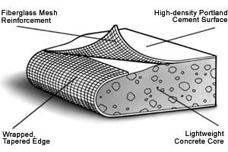

    - High density waterproof, moisture and mold resistant Backer Board
      - Product: ProTec by FinPan, Inc.
      - Base: Reinforced cementitious board
      - Thickness: [1/4 inch] [1/2 inch] [5/8 inch]
      - Width: 3 feet (914 mm)
      - Length: +5 feet (1524 mm)
      - Edges: Wrapped and tapered
      - Density: 88 lb. per cubic foot
      - ASTM C1325: Type A and B

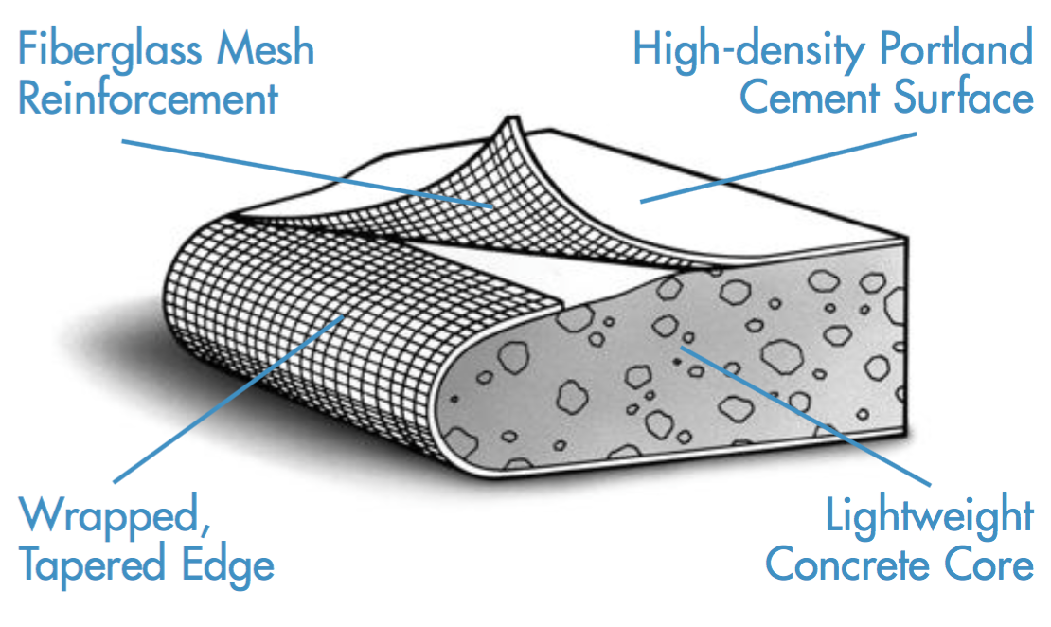
    - High Impact Resistant, Water, Moisture and Steam Resistant board:
      - Product: Util-A-Crete by FinPan, Inc.
      - Base: Alkaline resistant reinforced cementitious board
      - Thickness: [1/4 inch] [1/2 inch] [5/8 inch]
      - Width: 3 feet (914 mm).
      - Length: +5 feet (1524 mm).
      - Edges: Wrapped and Tapered
      - Density: 88 lb. per cubic foot
      - ASTM C1325: Type A and B
      - Compressive Strength: >2,600 psi
      - Flexural Strength: >1,500 psi
      - Fire Rating: 1-hr Rating (1/2” and 5/8” thickness)
      - Surface Burning: Flame Spread 5
Smoke Level 0

2.3 ACCESSORIES

A. Fasteners
1. Manufacturer’s recommended corrosion resistant screws.

B. Sealant/Adhesive:
1. Manufacturer’s recommended SIKA Flex 11 FC one part advanced polyurethane elastomeric sealant/adhesive.
    - Liquid Waterproofing:
      - Manufacturers Water Armor AWB VOC compliant, 100% acrylic air and water barrier for interior and exterior applications.
    - Seaming Tape:
      - Manufacturer’s alkali-resistant 2-inch (51 mm) wide fiberglass mesh tape for joint reinforcement.

F. Air and Damp Proofing Sealer:
1. Manufacturer’s recommended 100% acrylic sealer for vapor and damp proofing boards.
- EXECUTION
  - EXAMINATION
    - Verify framing is level, plumb and adjacent surfaces meet tolerances for installation.
    - For Floors, verify wall substrates are not to exceed maximum deflection allowed under all live, dead and impact and concentrated loads: "L" equals span length in inches.
      - L inches / 360 (L mm / 9144): For thin bed ceramic tile and brick installations.
      - L inches /480 (L mm / 12192): For thin bed stone installations.
    - Verify floor joists spacing do not exceed 19 inches on center.
    - For countertops to be tile finished, verify cabinet and wall surface are framed to meet countertop manufacturer’s tolerances.
    - Do not proceed with installation until unsatisfactory conditions have been corrected. Installation deems acceptance.
  - INSTALLATION
    - Review manufacturers instructions and submittals prior to installation.
    - Apply boards horizontally, with ends occurring over supports. Stagger end joints in adjacent rows on walls, ceilings and floors.
    - Cut boards to fit around openings and projections.
    - Mechanically fasten in accordance with manufacturer’s instructions.

    - Apply sealant, adhesive, seaming tape and liquid waterproofing as recommended by backer board manufacturer for a warranted installation.
    - Apply air and damp proofing sealer to boards in immediate contact with water and damp conditions.
  - FIELD QUALITY CONTROL
    - Repair or replace items damaged prior to installing final finished surfaces.

  - SCHEDULE
    - Levels of Finish:
      - High Impact Resistant board [enter location] [showers] [swimming pool walls] [janitor closets] [foyer] [entry] [stairwell] installed up to 6 foot room height and all exterior locations.
      - High Density board [at ceilings locations]
      - Lightweight waterproof insulated board [at perimeter wall locations for improved insulation values]

END OF SECTION

