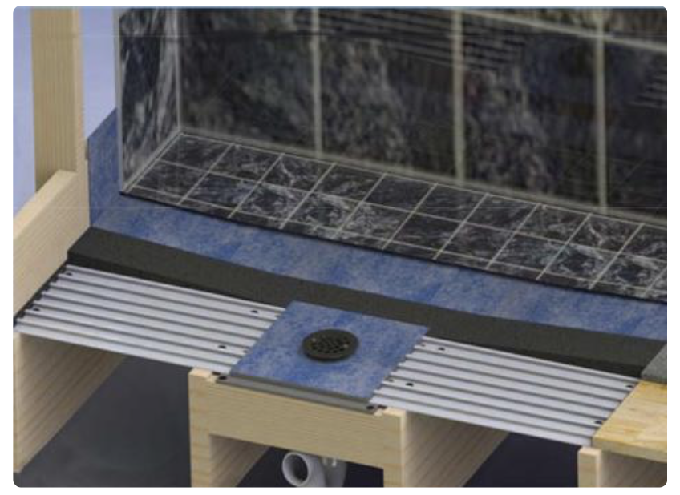
Note: Shower floor and wall system for wood framed structures, including residential, multifamily and other structures where zero (curb less) entry shower areas are desired.
Released 11/2018

SECTION 22 41 23
RESIDENTIAL SHOWERS

*******OR ********

SECTION 22 42 23
COMMERICAL SHOWERS

- GENERAL
  - SUMMARY
    - Section Includes:
      - Curbless, zero entry shower systems for above grade wood steel joints subfloors

  - RELATED SECTIONS

    - Division 01: Administrative, procedural, and temporary work requirements
    - Section [06 11 00 – Wood Framing]
    - Section [09 21 16.33 - Gypsum Board Area Separation Wall Assemblies]
    - Section [09 30 00 – Tiling]
    - Section [22 43 23 Healthcare Showers]
    - Section [22 45 13 Emergency Showers]
    - Section [22 46 19 Security Showers]
  - REFERENCES

    - American National Standards Institute (www.ANSI.org)
      - A118.9 - Test Methods and Specifications for Cementitious Backer Units.
      - A118.10 - American National Standard Specifications for Load Bearing, Bonded, Waterproof Membranes for Thin-set Ceramic Tile and Dimension Stone Installation.
      - A108.11 - Interior Installation of Cementitious Backer Units.
    - ASTM International (www.ASTM.org)
      - C947 Standard Test Method for Flexural Properties of Thin-Section Glass-Fiber-Reinforced Concrete
      - C1325 Standard for Non-Asbestos Fiber-Mat Reinforced Cementitious Backer Units
      - C1629 - Standard Classification for Abuse-Resistant Non-decorated Interior Gypsum Panel Products and Fiber-Reinforced Cement Panels
    - International Association of Plumbing and Mechanical Officials (www.IAPMO.org)
      - PS 46-2012, Field-Fabricated Tiling Kits
    - Tile Council of North America (www.TCNAtile.org)
      - TCNA Handbook.
  - SUBMITTALS

    - Submit under provisions of Section [01 30 00] - Administrative Requirements.
    - Manufacturer's data:
      - Each product to be installed
      - Accessory data
      - Installation requirements
      - Installer acceptance

C. Shop Drawings:
1. Dimensioned plans indicated layout of showers
    - Sustainable Design Submittals:
      - Regional Materials
      - Low-Emitting Materials
  - QUALITY ASSURANCE
    - Manufacturer Qualifications: Ten (10) years manufacturing moisture resistant backer boards.
    - Installer Qualifications: Five (5) years commercial tile or drywall installation experience.
  - DELIVERY, STORAGE, AND HANDLING
    - Deliver, store and handle product following manufacturer instructions.
    - Store indoors in manufacturer's packaging and protect from damage prior to installation.
    - Inspect components for damage and notify manufacturer of materials requiring replacement.
  - PROJECT CONDITIONS
    - Weatherproof and enclose building to maintain a minimum of 60 degrees F (15 degrees C) and 60% relative humidity.
  - WARRANTY
    - Provide manufacturer's ten (10) year repair or replacement warranty.
- PRODUCTS
  - MANUFACTURERS
    - Acceptable Manufacturer: FinPan, Inc. Hamilton, OH 45015; (800) 833-6444; www.finpan.com

    - Substitutions: [Not permitted] [In accordance with Section 01 16 00]
  - MATERIALS
    - Curbless Shower, zero entry system by FinPan, Inc.
      - Site fabricated assembly of the following components to produce a seamless tile ready wall and floor substrate for tiling.

        - Drain Plate: UPC rated drain, pre-sealed in drain plate for wood floor joists attachment.
1. Size: [13 x 13 inch Drain]
2. Material: Plastic
3. Color: Grey
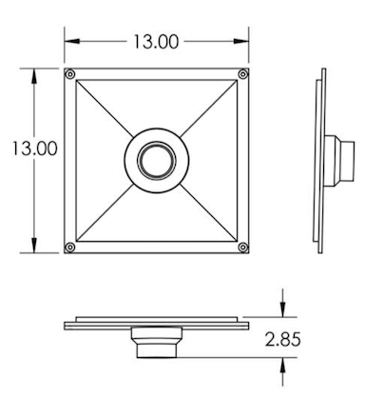
b. Drain Cover: Decorative cover finish.
1. Shape: [Round] [Square] [ClearLine 60 inch x 2.72 inch wide]

2. Round: [Stainless] [Oil Rubbed Bronze] [Bushed Nickel] [Antique Brass]
[Polished Brass]

*******OR*********
Cast Square: [Antique Bronze] [Brushed Nickel] [Oil Rubbed Bronze]
[Stainless Steel]
*******OR*********

Cast Round: [Brushed Brass] [Brushed Nickel]
*******OR*********
ClearLine: Stainless Steel [Standard] [Long Slot Grate] [Vertical Slot Grate] [Small Rectangles Grate]

        - Composite Structural Underlayment: TI-Proboard for interior and exterior wood substrates to provide a water resistant, non-warp, non-flex substrate for tiling.
          - Width: 1 foot
          - Length: up to 8 foot
          - Thickness: 3/8 inch
          - Composition: Fiberglass

        - PE Waterproofing Sheet Membrane:
          - Width: 39 inches
          - Length: Up to 25 feet
          - Thickness: 0.008 inches
          - Composition: Polyethylene

2.3 ACCESSORIES

A. Fasteners
1. Manufacturer’s recommended corrosion resistant screws.

B. Sealant/Adhesive:
1. Manufacturer’s recommended SIKA Flex 11 FC one part advanced polyurethane elastomeric sealant/adhesive.
C. Liquid Waterproofing:
1. Water Armor AWB VOC compliant, 100% acrylic air and water barrier for interior and exterior applications.
    - Seaming Tape:
      - Manufacturer’s alkali-resistant 2-inch (51 mm) wide fiberglass mesh tape for joint reinforcement.

E. Mortar Mix:
1. 4.1 Sand/ mortar mix as recommended by manufacturer.

F. Backer Board: ProPanel lightweight waterproof, insulated polystyrene polymer cement coated board. Wall Panel: ProPanel lightweight waterproof, insulated polystyrene polymer cement coated board.
1. Composition: High-density, polystyrene, fiber reinforced cement panel
2. ANSI A118.10: Section 4-5 Waterproofness
3. Thickness: [1/4 inch] [1/2 inch]
4. Weight: 6 pounds per panel
5. Width: 3 feet (914 mm).
6. Length: 5 feet (1524 mm).
7. Edges: Square.
8. Density: 2 lb. Density EPS Core
9. ASTM D4068: Pass, hydrostatic Water Pressure Test
10. ASTM G21: <10% , resistance to Fungi
11. ASTM C-627: Light commercial and Residential

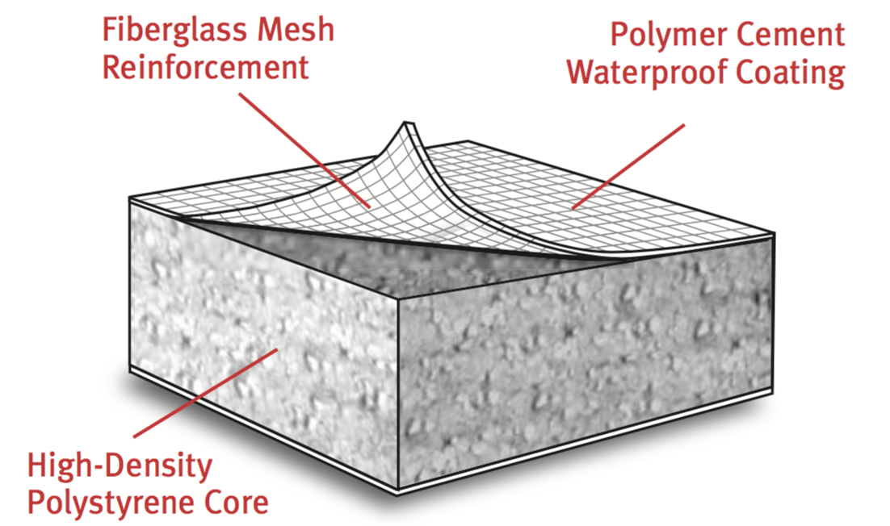
ProPanel Composition

- EXECUTION
  - EXAMINATION
    - Verify framing and joists are level, plumb and adjacent surfaces meet tolerances for installation.
    - For Floors, verify wall substrates are not to exceed maximum deflection allowed under all live, dead and impact and concentrated loads: "L" equals span length in inches.
      - L inches / 360 (L mm / 9144): For thin bed ceramic tile and brick installations.
      - L inches /480 (L mm / 12192): For thin bed stone installations.
    - Verify floor joists spacing do not exceed 19 inches on center.
    - Verify shower and drain plate locations will not impact under joists installations of sprinklers, electrical, plumping, hvac or other work to be installed.
    - Do not proceed with installation until unsatisfactory conditions have been corrected. Installation deems acceptance.
  - INSTALLATION
    - Review manufacturers instructions and submittals prior to installation. Install components in accordance with manufacturers requirements for a warranted installation.
    - Install drain plate to floor joists and any required blocking using recommended screws at each corner.
      - Maintain drain plate protection to prevent mortar and debris accumulation.
    - Loose lay composite structural panel perpendicular to the floor joists starting at drain plate edge.
      - Secure panel at using screws at each joist as required.
    - Install backer board to perimeter walls, securing to studs with screws.
E. Verify drain selection and proceed with installation as required.

    - Mix and apply 4:1 mortar and sand mix to fill in composite structure panel ribs.
      - Maintain a [5 percent][10 percent] slope to drain.

G. Apply thin-set to mortar surface and install waterproofing membrane to shower base and 6” up
backer board base.
- Waterproofing membrane is required on the face or behind backer boards that are not non-waterproof.
- Apply sealant and seaming tape to backer board joints and areas not watertight.

H. Apply liquid waterproofing as required, to maintain a watertight shower system.

I. Insert drain cover upon completion and secure to drain plate. Apply protective covering.
  - FIELD QUALITY CONTROL
    - Inspect drain, backer board and slope to drain upon completion. Repair as required for a warranted installation.
3.4 PROTECTION
A. Cover mortar and walls to protect from contamination and damage prior to tiling.

  - SCHEDULES
    - Shower:
      - Install at above grade [enter location]

END OF SECTION

